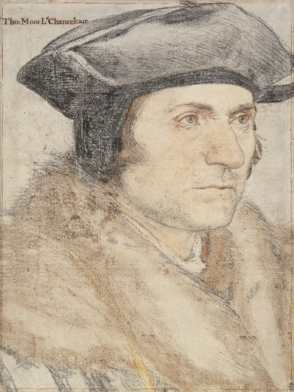

Thomas More by Hans Holbein the Younger

Saint Thomas More
An introduction for visitors to Allen Hall Seminary

Saint Thomas More (1478 – 1535)

Childhood and youth
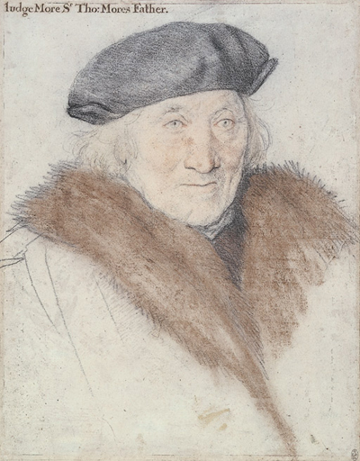
St Thomas was born on 7th February in either 1477 or 1478 in Milk Street in the City of London where his father was a judge. He was educated at St Anthony’s grammar school in Threadneedle Street (where the Bank of England now stands). At the age of twelve, Thomas was received into the household of John Morton, who as Archbishop of Canterbury and Lord Chancellor was the most powerful man in England after the King. The young Thomas was perhaps chosen as a favour to his father, who was well-known to the Archbishop. Thomas thus crossed the river and spent the next two years at Lambeth Palace, where he both served in the Archbishop’s household and also received daily schooling.
Morton was so impressed by Thomas’ intelligence and diligence that in autumn 1492 he sent him to Oxford to study under the Benedictine monks at Canterbury College (later absorbed into Christ Church). These studies would naturally have led Thomas towards a career within the Church, but after two years his father called him home so that he could train to become a lawyer. In February 1496 he was admitted as a student at Lincoln’s Inn, and he was called to the bar in 1501.
Sir John More, the father of Thomas More

Search for vocation
It is clear that Thomas experienced great struggles in his early twenties as he tried to discern his vocation in life. As a student of law it would have been customary for him not only to study but also to live at Lincoln’s Inn, but instead Thomas chose to live for a period of four years during this time at the Carthusian monastery at London Charterhouse. It was possible then for young men of spiritual tendency to lodge with the brothers while pursuing a secular career. Many such ‘guests’ were subsequently received into holy orders. Thomas was clearly attracted to the discipline, austerity and piety of the brothers’ lives. It is thought that this is when Thomas began wearing a hair shirt next to his skin. Although he did not take any vows, he did consult a friend already in holy orders, William Lily, about the possibility of being ordained as a priest.
However Thomas eventually decided that it would be difficult for him to live a life of celibacy. He told one friend that he feared becoming ‘an impure priest’ and that he felt called to the married life. In January 1505, at the age of twenty-six, he did indeed get married. His bride was Jane Colt, the daughter of a titled landowner and nearly ten years his junior. It seems to have been an extremely happy marriage and they had four children: Margaret, Elizabeth, Cecilia and John. Thomas bought a house for his young wife and ever-increasing family which was called The Barge, near the present-day Mansion House in the City of London.
However, Thomas suffered a great tragedy in his life in 1511 when his dear wife Jane died suddenly. Yet within a few weeks he had married again – a wealthy widow called Alice Middleton, whom he described as ‘neither a pearl or a girl’! She was eight years his senior, and brought with her a daughter from her previous marriage, making the ever-expanding More household predominately female.

Public life
Having decided that the consecrated life was not for him, Thomas turned his attention to finding a suitable career. He was passionate in his desire to play his part in public service. Henry VII in his reforms had brought lawyers as well as clerics to the heart of political affairs, so when Thomas began to shine in his legal work he was approached about serving as a member of Parliament. He readily agreed and was elected as a member for Middlesex, which made him one of some three hundred members of the Commons. They generally assembled in the Chapter House of Westminster Abbey but met rather infrequently, which allowed Thomas to continue his legal work. He was a brilliant and popular young man, renowned for his honesty and integrity, who was quickly noticed within political circles, which led to him being offered a series of official posts in government.
With the succession of Henry VIII in 1509, Thomas’ fortunes improved further. He served on the King’s Council and Star Chamber and became Speaker of the House of Commons. In the aftermath of Luther’s attack on the Church in 1517, Thomas was also increasingly involved in diplomatic missions abroad. His reputation grew as one of Europe’s leading thinkers as he engaged in debate with the great intellectuals of his day both in England and on the continent and also wrote in defence of the Catholic Faith against Martin Luther and William Tyndale. In 1517 he finished writing his most famous book, Utopia, which is the Greek word for ‘nowhere’. The book is about a mythical country with a perfect society.
In 1516 Thomas bought Crosby Place, which had been built in 1470 in Bishopsgate Street in the east of London by Sir John Crosby. Built of stone and timber, it was one of the most beautiful examples of late Gothic domestic architecture and in its day was the tallest private house in London. Thomas, as Speaker of the House of Commons, was obliged to keep an important household. (N.B. after More’s time the house passed from owner to owner until in 1674 most of it was burnt down. The imposing Great Hall survived, however, and in 1908 it was brought, piece by piece, to its current resting place in Danvers Street, just around the corner from Allen Hall, by the river.)
Thomas was knighted by King Henry in May 1521 and so became Sir Thomas More. Following Cardinal Wolsey’s fall from political grace, Sir Thomas was chosen on 26th November 1529 by Henry to be his Lord Chancellor, the first layman ever to hold this position. This made Thomas the most powerful man in England after the King. He was widely respected for his honesty and integrity in an age when bribery and corruption were an almost inevitable part of political life. As Lord Chancellor he was also the highest judge in the land, where once again he was celebrated for his conscientious service of justice as this verse of the time shows:

“When More some time had Chancellor been,
no more suits did remain.
The like will never more be seen
till More be there again.”
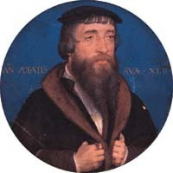
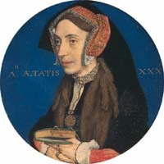
William Roper, More’s
son-in-law and
first biographer.
Margaret Roper, More’s eldest daughter, who was reputed to be the cleverest woman in England.

Thomas More in Chelsea

The Great House
As his political career flourished, Thomas looked for a new house for himself and his family. In 1524 he purchased twenty seven acres of land in Chelsea for £30, and seven and a half acres in Kensington for £20. It was here that he ordered the construction of ‘The Great House’, as it was known, for which he borrowed more than £700 from the King himself. Thanks to this financial assistance and the King’s energetic support, the house was built in a remarkably short space of time – it was begun in 1524 and finished in 1525.
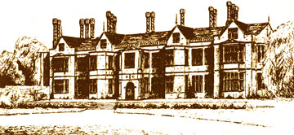

A reconstruction of St Thomas More’s ‘Great House’ at Chelsea, from a drawing in 1595 by J. Symands

Chelsea in those days was still a small village two miles outside of the city itself and was known for its clean, healthy air. It was also only two miles down-river from Westminster and was an area in which an increasing number of nobles had a country residence. There was also a royal manor here and the Bishop of Winchester had a house in Cheyne Walk, looking out onto the river. Contemporary accounts describe the Thames in Chelsea as full of salmon, perch and carp making it a popular area for fishermen (how things have changed!). The view from More’s Great House on the Chelsea side of the river would have been of the woods and pastures of Surrey on the other side of the river, while to the east the city of London would also have been visible. The steeple of St Paul’s could have been seen rising above the rooftops, and More built a special raised area in his garden from which he could better appreciate this view. This is how More’s great nephew, Father Ellis Heywood, described the house some years later:

“It is a beautiful and commodious residence, to which when fatigued with his occupation in the city he returned for refreshment and solace of retirement. After dinner, one descends about two stones’ throw into the garden, walks on a little lawn in the middle, then up a green hillock, where one halts to look around. It is an enchanting spot, as well from the convenience of the situation – from one side almost all the noble city of London being visible, and from the other the lovely Thames, being crowned with lovely flowers, and the sprays of the fruit trees so admirably spaced and interwoven, that looking at them they appear like a veritable piece of living tapestry made by nature herself.”

The land he had purchased was in the area now bordered to the north by the King’s Road (then only a small country lane), to the south by the river, to the west by Milman’s Street and to the east by Old Church Street. There had been a farmhouse or small manor house on the site, which was pulled down to make way for More’s larger dwelling of Tudor red-brick. Hans Holbein (who was a guest at the house in the late 1520’s) described it as being ‘dignified without being ostentatious’. The gardens were a particular interest of More’s and were filled with a rich variety of flowering shrubs, herbs and trees (including the famous mulberry trees which Thomas is thought to have planted because of their Latin name – Morus). There was also an orchard with apple, pear and plum trees as well as cottage gardens where vegetables and other food-stuffs for the household were grown.
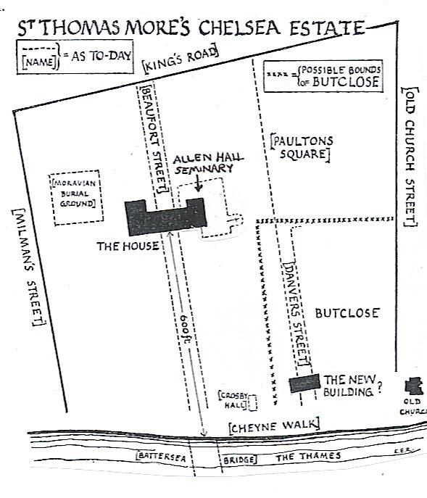
All the travelling to and from the Great House was done by barge, manned by liveried watermen. From Chelsea these barges were rowed down river to Westminster and the City, and sometimes Greenwich Palace, or up river to Hampton Court. The landing stage was at the bottom of the garden and was reached through a wicket gate. Here the More household would wave good-bye to Thomas on his way to the Court, wherever it happened to be.
In the grounds of the house More built a library and private chapel which became known as ‘The New Building’. In his daily routine Thomas tried to balance prayer and study in solitude with attending to his political and legal duties as well as spending time with his family. However he was often called away to attend the King and Council, and so his life at the Great House can be seen as a retreat from the cares and strains of court life.

Life in the Great House
William Roper, Thomas’ son-in-law, wrote this portrait of the More household in Chelsea:

“Dice, cards, and flirtation were forbidden…gardening, study, music, and matrimony were encouraged. There was household prayer every night that the master was at home, compulsory churchgoing on Sundays and feast days, and at the great feasts everyone had to rise to attend the midnight office. Usually More rose at 2 a.m. and gave the time till 7 a.m. to study and devotion. He heard Mass every morning… For devotion, More constructed at Chelsea ‘The New Building’, with its gallery, library, and chapel; there, so far as possible, he spent his Fridays in prayer and study, and on Good Friday the whole household was assembled there to hear the whole of our Lord’s Passion… At ordinary mealtimes one of the family read scripture, intoned in the monastic fashion, with the commentaries of Nicholas de Lyra. After the scripture had been discussed … More’s domestic fool was permitted to bring the conversation down to a lower level.”

The More household was extensive, including, as well as his wife and children, the foster-children and wards in his care. He was a gentle but strict, devoted and exacting father and guardian, concerning himself with every detail of their lives, particularly their education. It is interesting that he placed as much emphasis on the education of his daughters as he did on that of his son at a time when women’s need and right to be educated was largely ignored. Thus when his daughters married, their husbands joined the family circle and their studies continued. This is how Erasmus described More’s Chelsea household in a letter written in 1532 to his friend John Faber, Bishop of Vienna:

“More has built for himself on the banks of the Thames not far from London a country house that is dignified and adequate without being so magnificent as to excite envy. Here he lives happily with his family, consisting of his wife, his son and daughter-in-law, three daughters with their husbands and already eleven grandchildren. It would be difficult to find a man more fond of children than he. He has brought up his whole family in excellent studies…Almost everyone thinks learning useless to the reputation and good name of women, but More repudiates this idea and considers idleness a greater snare to them than literature…You would say that Plato’s Academy had come to life again. But I wrong More’s home in comparing it to Plato’s Academy, for in that latter the chief subjects of discussion were arithmetic, geometry and occasionally ethics, but the former deserved the name of a school for the knowledge and practice of the Christian faith.”

More had a natural gift for friendship, manifested in the warm hospitality offered to his many visitors of different rank and station. The Great House soon became a kind of intellectual club, which saw such regular guests such as John Fisher and also Erasmus, who had struck up a strong friendship with Thomas during a visit to England in 1499. Thomas hosted and often led great humanist discussions, while at the same time he set out to make the More household a place of learning for all his family. The most illustrious visitor to the Great House was, of course, King Henry, who would sail up the river from London in his state barge to talk to Thomas, his friend and counsellor. As William Roper later recorded in his biography of More, the two discussed “matters of astronomy, geometry, divinity and worldly affairs”.
Yet, it is important to stress that Thomas More did not desire to make the Great House a place mainly for state occasions and formal meetings – no, it was primarily a home in which the needs of his family were central. Hans Holbein, who was a guest at the Great house between 1526 and 1527, captured some of this joie de vivre in his famous portrait of the More family, a copy of which can still be seen in the National Portrait Gallery in London (there is also another copy in Chelsea Old Town Hall). A preparatory drawing for the portrait is shown below.
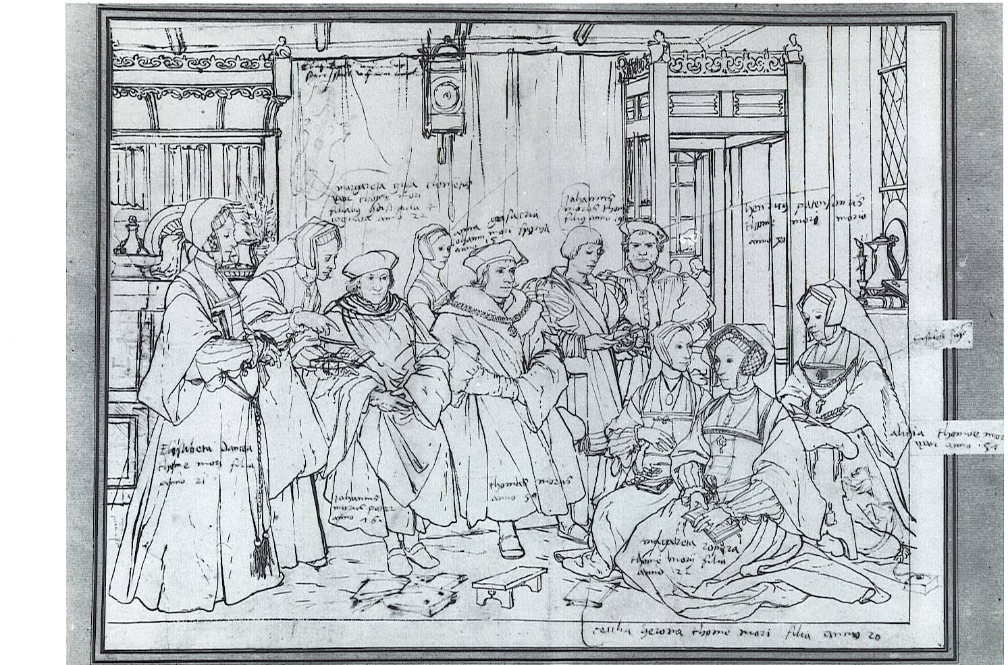

From left to right: Elizabeth Daunce, More’s second daughter; Margaret Clements, née Giggs, a cousin More brought up; Sir John, who died in 1530; Anne Cresacre, an orphan who in 1529 married John; Sir Thomas, whose age 50, dates the composition; John, his only son; his domestic fool, Henry Patenson; Cecily Heron, More’s third daughter; Margaret Roper, alias, Meg, his eldest child; Alice Middleton, his second wife.

The room in which the family is sitting is full of flowers, books, musical instruments and even some animals. Yet the focus of the painting is the rich variety of individuals who make up this family group – we can almost hear the chatter and banter between them coming out from the canvas. On Thomas’ left sits his father, Sir John More, who lived with his son. Sir John remarried twice, possibly even three times after the death of Thomas’ mother, Agnes. Erasmus wrote these words to a friend about Thomas’ relations with this succession of stepmothers:

“It would be difficult to find anyone living on such good terms with their mother as More does with his stepmother. His father has brought in one stepmother after another, and he has been as affectionate with each one of them as with his mother. The father has already introduced a third, and More swears he never saw anything better.”

On the far right of the portrait is Thomas’s second wife, Alice, to whom he paid public tribute in the epitaph he wrote for his first wife, which can still be seen in Chelsea Old Church:

“Here lies Joanna, dear little wife of Thomas More, who intends this tomb for Alice and me. The first united to me in my youthful days, gave me a boy and three girls to call me father. The second, a rare distinction in a stepmother, was as affectionate as if the children were her own. It is hard to say if the first lived with me more beloved than the second does now. Oh how blessed if fate and religion had permitted all three of us to live together. I pray the tomb and heaven may unite us, thus death could give what life could not give.”

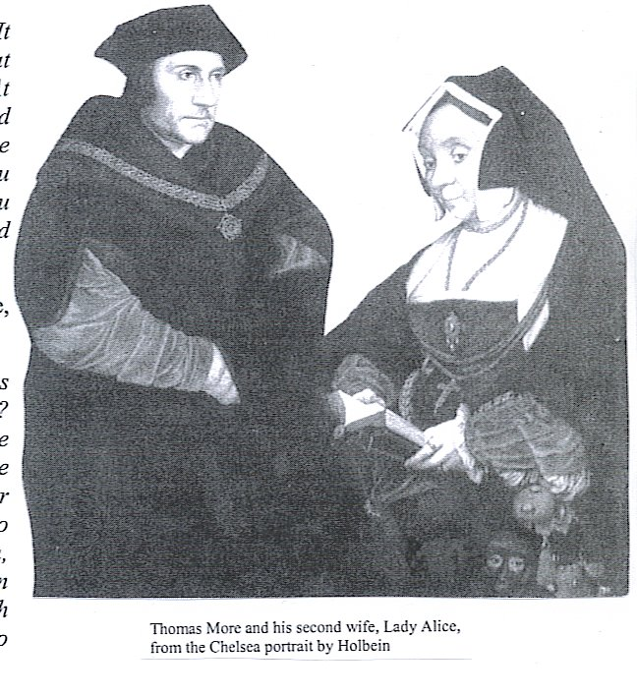
Dame Alice, as she became, shared with Thomas a great love of animals. Alice was fond of them as household pets, whereas More had a great curiosity about their behaviour and loved to study their habits. Amongst the menagerie at the Great House were apes, monkeys (one appears in Holbein’s portrait), weasels, ferrets, rabbits and, of course, dogs. Alice’s heart went out to any stray animal, a trait which the following account reveals sometimes led her into trouble:

“Dame Alice loved little dogs to play with. It happened that she was presented with one that had been stolen from a beggar woman. At length Sir Thomas got to hear of it, so caused both his wife and the beggar to come before him in the hall, and said – “Wife come you here, at the upper end of the hall, because you are a gentlewoman, and you good wife stand beneath, because you shall have no wrong.”

Thomas then placed himself in the middle, and held the dog in his hands, saying to them:

“Are you content that I shall decide this controversy between you concerning this dog? - “Yes” they said. Then each of you call the dog by name and to whom the dog comes, she shall have it. The dog came to the poor woman, so he caused the dog to be given to her, and gave her, besides, a French crown, and desired that she should bestow the dog on his Lady. The poor woman was well paid with his fair speeches, and his alms, and so delivered the dog to my Lady.”

Saint Thomas in his local community
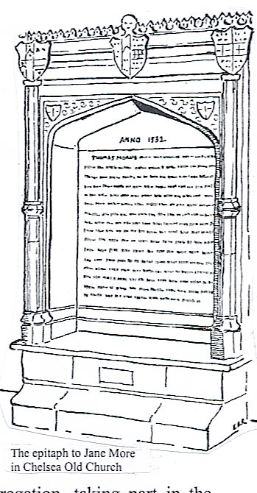
There was a small village church close to the Great House, dating back to at least Norman times and dedicated to All Saints. Soon after arriving in Chelsea, More restored its largest chapel as a ‘family chapel’. The date of this work – 1528 – is inscribed on one of the capitals of the pillars leading to the Chancel. These capitals are alleged to have been redesigned by Holbein and bear the symbols of More’s offices in Church and State along with his coat of arms and crest. It is possible that Thomas was in ‘minor orders’ (a possible legacy of his four years spent with the monks at Charterhouse), which would explain the ecclesiastical symbols carved on the western capital – the tapers, the processional candlesticks, the holy water pail and brush, and the Gospel book. The eastern capital bears, in addition to the date, corresponding civil emblems – his coat of arms and crest, a crossed sword and sceptre, and an object which some have explained as the mace of the Lord Chancellor. The vault of the chapel of the chapel was also restored and was designed by More to be his family’s last resting place. He had the remains of his first wife, Jane, transported here and he composed a fine epitaph in which he expressed the wish that he and his second wife Alice might one day lie beside her.
He was a frequent and active member of the little congregation, taking part in the processions and acting as an altar-server at the Mass. It seems that he even donned a surplice and sang in the choir; when the Duke of Norfolk criticised him for performing such a humble role, he is reported to have replied, “My master the King cannot be displeased at the service I pay to his master God.” There is another story of him walking around the parish boundary on foot with the rest of the congregation; when offered a horse because of his rank as a knight, he is supposed to have answered, “My Lord went on foot. I will not follow him on horseback.” He walked, too, on pilgrimages to the shrines outside London; that of Our Lady of Willesden being held by him in particular veneration.
Finally, Thomas became well-known for his charitable endeavours in Chelsea – visiting the poorer inhabitants of the village and giving generously of his money. When his official duties prevented him from dispensing alms, he instructed other members of his family to take his place. He often invited those in need to join his family at dinner, and he brought the sick or the dispossessed into the shelter of his house. He maintained, for example, a poor widow called Paula, who had lost everything in the courts of London. Eventually he established a separate house for the poor, the infirm and the elderly, which was supervised by his daughter Margaret.
His attitude of feeling a keen responsibility for the neighbouring poor in Chelsea is clear in the only surviving letter to Alice, which he wrote in 1529 following a fire which had disastrously burnt down the barns on the estate of the Great House. The barns had also been used by poor neighbours in Chelsea to store corn. Dame Alice sent Giles Heron, his son-in-law, to convey the bad news to her husband, who was at Woodstock with the King. Thomas immediately wrote Alice a letter, which incidentally shows his high opinion of her ability to cope with such a crisis and manage the estate in his absence:

“I pray you make good search what my good neighbours have lost, and bid them take no thought thereon, for I should not leave myself a spoon, there shall be no poor neighbour of mine bear no loss by any chance happening in my house. I pray you be with my children and your household merry in God. Be of good cheer and take all the household with you to Church, and there thank God both for what he hath given us, and for what he hath left us.”

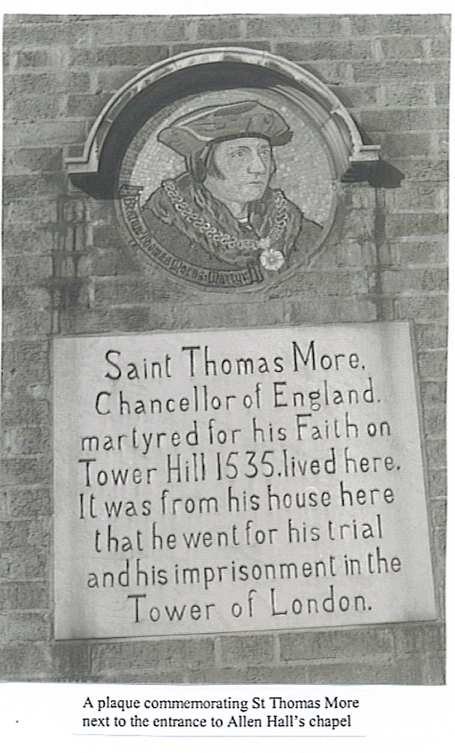
Farewell to Chelsea
You will remember from William Roper’s biography of his father-in-law how King Henry used to visit his friend Thomas at the Great House to discuss “matters of astronomy, geometry, divinity and worldly affairs”. It was the ‘worldly affairs’ which were, of course, to lead to More’s fall from political grace. By 1530 Henry was moving towards the ‘great matter’ – the divorce from his wife, Catherine of Aragon and a new marriage to Anne Boleyn. The ‘great matter’ had already brought down Cardinal Wolsey, the previous Lord Chancellor, and when the King went his own way and divorced Catherine, More resigned the Chancellorship in May 1532.
Although it seems that Thomas hoped to ride out the storm in the seclusion of his Chelsea estate, Henry’s declaration that he was the Supreme Head of the Church in England was a move which More could not support. More knew that Henry’s marriage to Catherine was valid and that the Pope, as the successor of Peter, ruled the whole Church. Knowing that his decision would be deemed treasonable, More left Chelsea on 17th April 1534 and, after making his confession to Dr Lark, the Rector of Chelsea, took a boat to Lambeth where he made a formal refusal of the Supremacy Oath. He was never to return to his beloved Chelsea home.
This is how William Roper in his Life of More describes what was to be for More his last morning in Chelsea:

“Then Sir Thomas More, as his accustomed manner was always, ere he entered into any matter of importance, as when he was first chosen for the King’s Privy Councillor, or when he took any weighty matter upon him, would go to church and be confessed, and hear Mass, and be houseled [take communion]; so did he likewise in the early morning, the selfsame day that he was summoned to appear before the lords at Lambeth.
And whereas he ever more used, before at his departure from his wife and children, who he tenderly loved, to have them bring him to his boat there to kiss them all, and bid them farewell, then would he suffer none of them forth of the gate, to follow him, but pulled the wicket gate after him, and shut them all from him with a heavy heart, as by his countenance appeared. With me and our four servants there, took he his boat towards Lambeth…wherein still sitting sadly awhile, at last he suddenly rounded me in the ear, and said, “Son Roper, I thank Our Lord, the field is won.” What he meant thereby, I whist not, yet loath to seem ignorant, I answered, - “Sir, I am therefore very glad.”

Imprisonment and Execution
Although More had refused to take the oath declaring Henry to be supreme head of the Church, he used all his lawyer’s skills and tactics to avoid being found guilty of open treason. He knew that silence was his best defence. Thus he declined to discuss the supremacy nor would he criticise others who had sworn and signed. However, Henry could not afford even tacit dissent from such an important figure, who was respected and admired not only in England but across Europe. As Thomas Cromwell exclaims in A Man for All Seasons, “His silence is deafening all Europe”. More was therefore arrested and taken to the Tower of London.
When More reached the Tower in April 1534, he seems at first to have been reasonably well-treated. He had enough clothing and a number of books and a servant called John Wood to look after him. After a month his beloved daughter Margaret obtained permission from the king to see her father, and from William Roper we know of at least one visit by Lady Alice. The door of his cell was locked only at night and he was able to walk in the garden, maybe even to attend mass. Early on 4th May 1535, More and Margaret watched from his cell three Carthusian monks and two other priests being led past his window on their way to Tyburn where they were hung, drawn and quartered for opposing the Supremacy Act. As they passed by, More said to his daughter, “Do you not see, Meg, that these blessed fathers are now as cheerfully going to their deaths as bridegrooms to their marriage?”
More spent his time in prayer, reading and writing. When deprived of ink, he would make himself pencils of charcoal. During this time he was composing a meditation in Latin on how Christians should accept suffering, using as an example Christ’s agony in the garden of Gethsemene. He had reached the point where the guards laid hands on Jesus when Cromwell ordered all his books and writing materials to be removed.
Yet throughout the time of his imprisonment the source of More’s greatest sufferings was arguably his own family. No one in the family could understand his “scruple of conscience”. Lady Alice was especially opposed. William Roper records that when she was finally able to see her husband for the first time in prison, she “bluntly” greeted him with these words:

“Master More, I marvel that you, who have always been taken for such a wise man, should now play such a fool as to lie here in this tiny, filthy prison and be content to be shut up with rats and mice when you could be about and at your liberty, and with the favour and goodwill both of the King and his Council, if you would do as all the bishops and best learned of this realm have done.”

After quietly listening to her long reproof, More “with a cheerful expression said to her,
“Is not this house as close to heaven as my own?”
To which she, not liking such talk, answered, “Tilly-vally, tilly-vally!”
“But what do you say, Mistress Alice,” he asked, “Is it not so?”

Next Alice “kept on pleading and harping on a long life”, so Thomas finally said:
“How long, my Alice, shall I be able to enjoy this life?”
“A full twenty years, if God so wills.”
“Do you wish me, then, to exchange eternity for twenty years? Here, good wife, you do
not bargain very skilfully.”

Most painful to More was the opposition of his beloved eldest daughter, Margaret, a well-educated woman perfectly capable of understanding the issues involved, who nevertheless begged him to take the oath. But the answer was always the same; he could not in conscience acknowledge what was untrue. Once when Meg visited him in prison and tried to persuade him to come home for his own good and that of the family, he gently refused calling her “mistress Eve…come to offer father Adam the apple yet again.”

Meanwhile, Henry and Cromwell were continuing to work towards More’s execution. Imprisonment was no longer a sufficient punishment for such a public and effective sign of opposition. More was brought to trial after fifteen months of imprisonment on July 1st 1535. His opponents had worked hard to prepare the trial - it had taken almost sixteen months, two sessions of Parliament and considerable manipulation to bring him to court. He appeared before fifteen judges and twelve jurors – yet these were far from impartial. The judges included Lord Chancellor Audley, Royal Secretary Cromwell, and the Duke of Norfolk, as well as an uncle, a brother and the father of Ann Boleyn – all of whom had strong interests in convicting More. Although physically weak after his long imprisonment, More conducted his own defence.
More was convicted on the basis of the false testimony of the Solicitor-General, Richard Rich, who claimed that while visiting More’s cell on June 12th 1535, More had explicitly denied Parliament’s authority to make Henry the supreme head of the Church in England. More strenuously denied such a claim and took an oath, calling God to be his witness, saying:

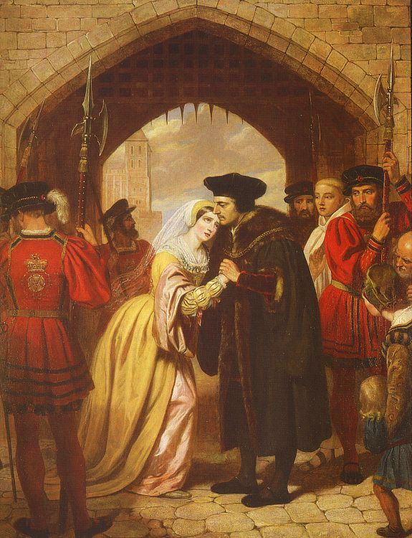
“If I were a man, my lords, who did not reverence an oath, I need not, as is well known, stand here as an accused person in this place, at this time, or in this case. And if this oath of yours, Master Rich, be true, then I pray that I never see God in the face, which I would not say, were it otherwise, to win the whole world… In good faith, Master Rich, I am sorrier for your perjury than for my own peril.”

Although More not only successfully proved that all the charges against him were false but also showed that the entire legal foundation of the trial was contrary to the law, the jury took only fifteen minutes to return its verdict: “Guilty”.
As More was led away back to his cell in the Tower, his son John threw himself at his feet and asked for a blessing. At Tower Wharf, a distraught Margaret, “pressing in among the midst of the throng, hastily ran to him and there openly, in the sights of them all, embraced him, took him about the neck and kissed him.” In his last letter, written from the condemned cell with “a piece of coal”, More admitted that these gestures had moved him. “I liked well you natural feelings,” he wrote to John; and as for Margaret: “I never liked your manner towards me better than when you kissed me last. For I love when daughterly love and dear charity hath no leisure to look to worldly courtesy.” It was to Margaret that More, on the eve of his execution, sent his hair shirt with this final letter, in which he wrote, “Tomorrow long I to go to God.”
Early in the morning of 6th July 1535 More left his cell dressed in a coarse garment, carrying a red cross of his own making and was taken to the scaffold on Tower Green. Here he knelt down to recite psalm 51, Miserere mei, Deus, and then rose up to say his final words. A royal messenger had warned Thomas that his family would suffer if his speech was overlong. Instead More simply asked the bystanders to pray for him, as he would pray for them elsewhere. He then begged them to pray for the King, that it might please God to give him good counsel. His final words were: “I die the King’s good servant, but God’s first.”
His severed head was put on a stake on London Bridge and his body was buried in the church of St Peter ad Vincula inside the Tower. Later on Margaret came in a boat by night and by bribing the watchman had her father’s head thrown down into her lap. It is believed to remain today in the Roper vault behind an iron grille in St Dunstan’s Church, Canterbury.

Reflections on the Sainthood of St Thomas More
On May 19th 1935 Thomas More and John Fisher were canonized by Pope Pius XI. During his homily Pope Pius said of More:

“Endowed with the keenest of minds and supreme versatility in every kind of knowledge, he enjoyed such esteem and favour among his fellow-citizens that he was soon able to reach the highest grades of public office. But he was no less distinguished for his desire of Christian perfection and his zeal for the salvation of souls. Of this we have testimony in the ardour of his prayer, in the fervour with which he recited, whenever he could, the Canonical Hours, in the practice of those penances by which he kept his body in subjection, and finally in the numerous and renowned accomplishments of both the spoken and the written word which he achieved for the defence of the Catholic faith and for the safeguarding of Christian morality. A strong and courageous spirit, like John Fisher, when he saw that the doctrines of the Church were gravely endangered, he knew how to despise resolutely the flattery of human respect, how to resist, in accordance with his duty, the supreme head of the State when there was question of things commanded by God and the Church, and how to renounce with dignity the high office with which he was invested. It was for these motives that he too was imprisoned, nor could the tears of his wife and children make him swerve from the path of truth and virtue. In that terrible hour of trial he raised his eyes to heaven, and proved himself a bright example of Christian fortitude. Thus it was that he who not many years before had written a work emphasizing the duty of Catholics to defend their faith even at the cost of their lives, was seen to walk cheerful and confident from his prison to death, and thence to take his flight to the joys of eternal beatitude.”

On May 28th 1982 Pope John Paul II spoke of More and Fisher during his homily in Westminster Cathedral at the beginning of his historic pilgrimage to Great Britain:

“London is particularly proud of two outstanding saints, great men also by the world’s standards, contributors to your national heritage, John Fisher and Thomas More.
John Fisher, the Cambridge scholar of Renaissance learning, became Bishop of Rochester. He is an example to all Bishops in his loyalty to the faith and in his devoted attention to the people of his diocese, especially the poor and sick. Thomas More was a model layman living the Gospel to the full. He was a fine scholar and an ornament to his profession, a loving husband and father, humble in prosperity, courageous in adversity, humorous and godly. Together they served God and their country – Bishop and layman. Together they died, victims of an unhappy age. Today we have the grace, all of us, to proclaim their greatness and to thank God for giving such men to England.”

On 31st October 2000 Pope John Paul II declared Thomas More the patron saint of statesmen/women and politicians. In his apostolic letter the Pope identified certain saintly qualities which Thomas More displayed in his life and death:

1) A Man of Conscience
“The life and martyrdom of Saint Thomas More have been the source of a message which spans the centuries and which speaks to people everywhere of the inalienable dignity of the human conscience, which, as the Second Vatican Council reminds us, is “the most intimate centre and sanctuary of a person, in which he or she is alone with God, whose voice echoes within them” (Gaudium et Spes, 16). Whenever men or women heed the call of truth, their conscience then guides their actions reliably towards good. Precisely because of the witness he bore, even at the price of his life, to the primacy of truth over power, Thomas More is venerated as an imperishable example of moral integrity. And even outside the Church, particularly among those with responsibility for the destinies of peoples, he is acknowledged as a source of inspiration for a political system which has its supreme goal the service of the human person.”

2) A Model Catholic Layman and Family Man
“Throughout his life he was an affectionate and faithful husband and father, deeply involved in his children’s religious, moral and intellectual education. His house offered a welcome to his children’s spouses and his grandchildren, and was always open to his many young friends in search of the truth or of their own calling in life. Family life also gave him ample opportunity for prayer in common and lectio divina, as well as for happy and wholesome relaxation. Thomas attended daily Mass in the parish church, but the austere penances which he practised were known only to his immediate family.”

3) A life of Public Service
“[More] distinguished himself by his constant fidelity to legitimate authority and institutions precisely in his intention to serve not power but the supreme ideal of justice. His life teaches us that government is above all an exercise of virtue. Unwavering in this rigorous moral stance, this English statesman placed his own public activity at the service of the person, especially if that person was weak or poor; he dealt with social controversies with a superb sense of fairness; he was vigorously committed to favouring and defending the family; he supported the all-round education of the young. His profound detachment from honours and wealth, his serene and joyful humility, his balanced knowledge of human nature and of the vanity of success, his certainty of judgement rooted in faith: these all gave him that inner strength that sustained him in adversity and in the face of death. His sanctity shone forth in his martyrdom, but it had been prepared by an entire life of work devoted to God and neighbour.”

Finally, Father Germain Marc’hadour, one of the most widely respected More scholars of the twentieth century, published the following reflection in 1961:

“It may be that the near future will face all of us with the problem of harmonizing, or simply reconciling, our loyalty to Caesar with our loyalty to God…Caesar, moreover, is no longer a monarch; he is a cabinet, or party…he is public opinion, which shapes – and is shaped by – the newspapers, the broadcasts, the schools…
If we may bring a few examples, there are today fields of conduct, such as divorce, sexual behaviour and education, the use of artificial contraceptives, abortion, mercy killing… in which a Catholic, especially if he is a lawyer, a doctor, a nurse, or a teacher, will find himself alone against practically everyone else in his profession…the Catholic will sometimes be alone of his species in the whole street…He will even find fellow Catholics ready to taunt him…In extreme cases fidelity to the doctrine of Mother Church will mean worse than corporal death: it will alienate from a man the trust and esteem of the people he likes, or even loves, best…The prospect of this social disqualification…is as strong and effective a pressure as the old forms of physical duress…
If ever we lack wisdom to decide where the golden measure of Christian obedience lies, or grace and energy to carry out its implications when we are bleakly isolated in a hostile environment, let us turn to him [More]. The obedience of one man redeems the sins of many. The fervent intercession of one saint can remedy the sickly reluctance of many tepid Christians. He is a dangerous patron and a dangerous friend, “a nuisance of a saint,” who never believed in being carried to heaven on a featherbed. He will not teach us an easy way, but he will show us where we can find the comfort we need to suffer our freely accepted discomforts.”

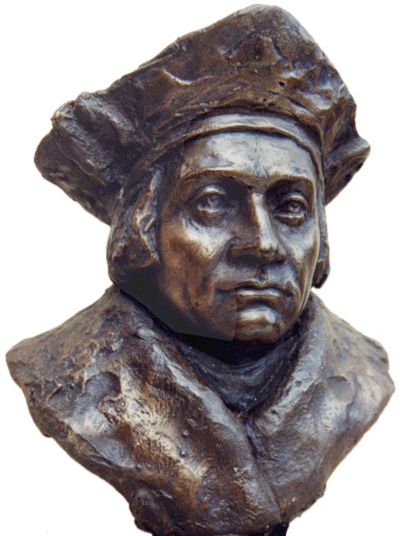



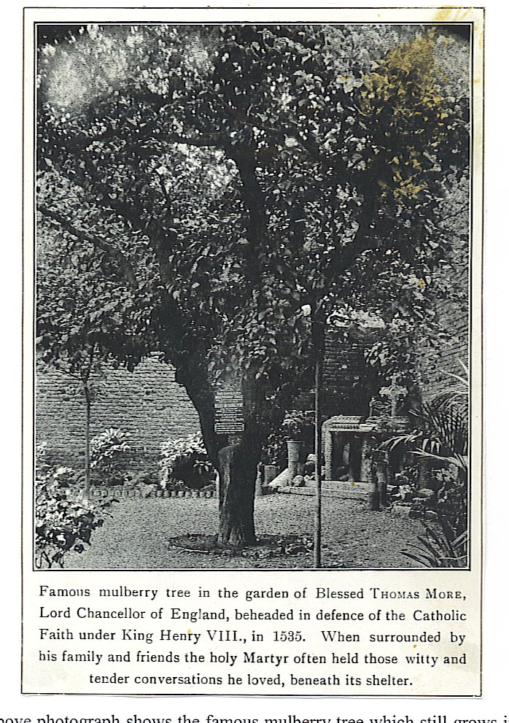

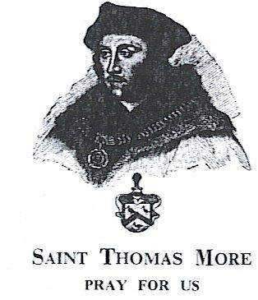
The above photograph shows the famous mulberry tree which still grows in the grounds of Allen Hall and is believed to date back to the time of Saint Thomas. The photograph was taken in the early twentieth century, when part of the grounds of More’s Great House was occupied by the convent of the sisters of the Adoration Réparatrice. Since 1975 this site in Beaufort Street has been the home of Allen Hall, the diocesan seminary for the Archdiocese of Westminster. Saint Thomas would surely have enjoyed the irony of the fact that almost five hundred years after he gave his life to defend the Catholic faith in England, his home has now become a place where future Catholic priests receive their training. We, staff and students of Allen Hall, would like to gratefully express our debt to Saint Thomas and humbly ask for your prayers as we strive to be worthy witnesses to the faith which he gave his life to defend.

The things
Good Lord,
that I pray for
give me thy grace
to labour for.

